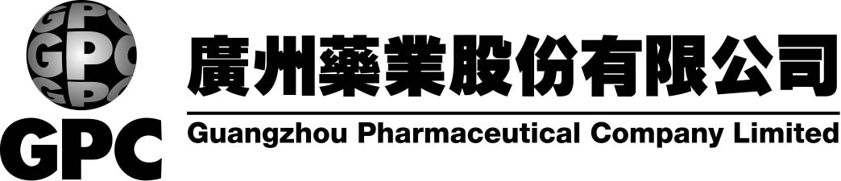
(a joint stock company with limited liability established in the People’s Republic of China)
Announcement
Resolutions passed in the third meeting
of the Second Board of Directors
The third meeting of the second board of directors of Guangzhou Pharmaceutical Company Limited (the “Company”) was held on 21 February, 2001 in the conference room on the second floor of the Company’s premises. The meeting was chaired by the Chairman, Mr. Cai Zhixiang, and attended by six out of nine directors. In accordance with the requirements of the Company Law of the People’s Republic of China (“PRC”) and the Articles of Association of the Company, the supervisors and senior management staff were present at the meeting. The attending directors, after due discussion, resolved unanimously to pass the following resolutions:
1. | It was resolved that Kwang Chow First Chinese Medicine Factory takes over Guangzhou Zhong Sheng Pharmaceutical Factory and Kwang Chow First Chinese Medicine Factory be authorized to implement the take over in accordance with the PRC laws (both Kwang Chow First Chinese Medicine Factory and Guangzhou Zhong Sheng Pharmaceutical Factory are subsidiaries of the Company).
2. | It was approved that Beijing University of Chinese Medicine and Pharmacology transfers to Guangzhou Pharmaceutical and Industrial Research Institute its 30% interest in Advanced Technology Centre for Chinese Medicine (which was jointly established by Beijing University of Chinese Medicine and Pharmacology and the Company), while the Company agrees to waive its pre-emptive right and the name of Advanced Technology Centre for Chinese Medicine be changed.
3. | It was resolved that an investment management committee be formed under the board of directors and be authorized by the board of directors to exercise the following functions:
 | (1) | to review the annual consolidated investment plans and investment proposals of the Company;
 | (2) | to review and monitor the investment plans and the investment projects of the subsidiaries of the Company;
 | (3) | to review and approve investments (including acquisitions and mergers) with an investment amount per transaction of less than 3% of the total net assets of the Company and an annual aggregate investment amount of less than 10% of the total net assets of the Company;
 | (4) | to review and approve short-term investments (only limited to any single transaction with an investment amount of less than 3% of the net assets of the Company and an annual aggregate investment amount of less than 10% of the net assets of the Company);
 | (5) | to review, approve and administer other investment plans assigned by the board of directors.

The composition of the investment management committee is as follows:
Chairman: | Cai Zhixiang
Vice chairman: | Li Yimin
Committee members: | Chen Xiangzhi, Xiao Cheng, Jiang Shijie, He Shuhua, Xiang Zhihang

The Board of Directors
Guangzhou Pharmaceutical Company Limited
22 February, 2001

Please also refer to the published version of this announcement in the i Mail dated 23/2/2001.

